**A PROJECT REPORT**

**ON**

**“AI Generated Music”**

**Submission to**

**Bennett University**



**In Partial Fulfilment of the Requirement for the Award of MASTERS’S DEGREE IN**

**COMPUTER APPLICATION**

**BY**

**ABHISHEK GUPTA**

**E22MCAG0032**

**UNDER THE GUIDEANCE**

OF

**Dr. Suneet Kumar Gupta**

**ABSTRACT**

Title: Music generation with Artificial Intelligence

AI-generated music has emerged as a fascinating field in the intersection of music and artificial intelligence. The aim of this report is to provide an overview of the AI-generated music, its current state, and the challenges faced in its development. This report analyzes the proposed solution, implementation, and results obtained from an AI-generated music project. The report will also discuss the potential of AI-generated music and its impact on the music industry.

**Contents**

|  |  |
| --- | --- |
| **1 Introduction**  1.1 Purpose | **1** |
|  |
| 1.2 Project Scope |  |
| 1.3 Related Work  2 **Problem Statement**  **3.Requirement Analysis, Risk Analysis, Feasibility Analysis**  **3.1 Development environment**  **3.2 Production environment**  **4. External Interface Requirements** **User Interfaces** **4.2.2 Hardware Interfaces** **Software Interfaces** **5.Proposed Solution or Approach or Technique**  **6. USE CASE DIAGRAM** |  |
|  |  |

**Chapter 1**

**Introduction**

The use of artificial intelligence in music generation has gained a lot of attention in recent years. AI-generated music refers to the music that is created using machine learning algorithms and neural networks. The use of AI-generated music has the potential to revolutionize the music industry by creating new sounds and compositions that were previously impossible. This project aimed to develop an AI system that could generate original compositions based on a given set of inputs.

* 1. **Purpose**

Using AI as a tool to make music or aid musicians. Composing a new music will become easier. The objective of this project is to generate music using Neural Networks. The model will be predicting monophonic music notes to generate new music.

* 1. **Project Scope**

The basic idea is to generate music using A.I or more specifically by using neural networks. We will use attention mechanism to generate future music notes. Using attention mechanism, our model will be able to choose which previous notes to focus on in order to predict which notes will appear next. Artificial intelligence is also helping the industry with A&R (artist and repertoire) discovery. It’s always been challenging to comb through music and find promising artists that haven’t signed to a label, but it’s even more overwhelming with the deluge of streaming music today. Warner Music Group acquired a tech start-up last year that uses an algorithm to review social, streaming and touring data to find promising talent. Apple also acquired a start- up that specializes in music analytics to support the A&R process. AI is behind the scenes influencing the music we listen to in many ways.

* 1. **Related Work**

Several studies have been conducted on AI-generated music. Some notable works include the BachBot, which used machine learning to generate compositions in the style of Johann Sebastian Bach. Another study used a recurrent neural network to generate music in the style of various artists, including the Beatles and Mozart. These studies demonstrated the potential of AI-generated music and laid the foundation for further research in this field.

**2.Problem Statement**

The development of AI-generated music systems is challenging due to the complex nature of music. Music is a highly subjective and creative art form, and creating a system that can generate music that is aesthetically pleasing to humans is a difficult task. Another challenge is the need to balance between creativity and predictability, as AI-generated music must be original but not too unpredictable.

**3.Requirement Analysis, Risk Analysis, Feasibility Analysis**

The project team conducted a thorough analysis of the requirements for the AI-generated music system. The team also conducted a risk analysis to identify potential risks and develop mitigation strategies. Feasibility analysis was also conducted to determine the practicality of the project and identify any potential limitations.

**3.1 Development environment:**

Software requirements : python (used v3.7), tensorflow (v2.2 used), numpy, matplotlib, music21

Hardware requirements: 4 core CPU, RAM 16GB, GPU Tesla K80 12GB

**3.2 Production environment:**

Software requirements: python (v3.7 or above), music21

Since the output generated by the model is in the format ‘.midi’ we will need music21 library to process and listen to the output.

Hardware requirements: 2 core CPU, RAM 4GB, audio output device.

# External Interface Requirements

## User Interfaces

Since the output is a ‘.midi’ file it has to be run in python. We have chosen to generate the final output file by running command through terminal.

## Hardware Interfaces

User will type the execution command to run the python script through keyboard to generate the output file that will be stored in the folder.

## Software Interfaces

The program is compatible with every operating system. The tools used are Jupyter Notebooks, Google Colab. In addition the libraries used are Keras, TensorFlow, music21 and many others.

**5.Proposed Solution or Approach or Technique:**

The proposed solution for the AI-generated music system involved the use of a deep learning neural network to learn the patterns and structures of music. The system was trained using a large dataset of music compositions, and the network was optimized using various techniques, including regularization and dropout. The system was also designed to generate music based on user inputs, such as the desired style, tempo, and melody. The AI-generated music system architecture consisted of a data processing module, a neural network module, and a music generation module. The data processing module was responsible for processing and cleaning the music dataset. The neural network module was responsible for learning the patterns and structures of the music. The music generation module was responsible for generating new compositions based on the user inputs.

**6.** **USE CASE DIAGRAM, DFD:**

The AI-generated music system architecture consisted of a data

processing module, a neural network module, and a music generation

module. The data processing module was responsible for processing

and cleaning the music dataset. The neural network module was

responsible for learning the patterns and structures of the music. The

music generation module was responsible for generating new

compositions based on the user inputs.

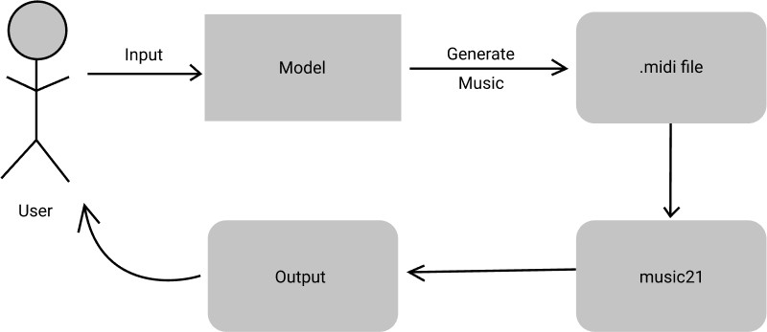USE CASE DIAGRAM

**DATA FLOW DIAGRAM**

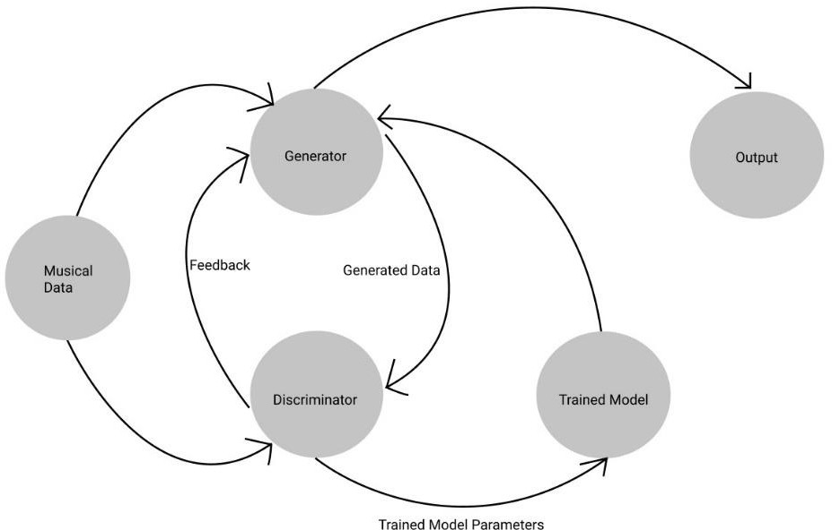

**Simulation Set up and Implementation:**

We used Python and TensorFlow to implement the Music Transformer model. We trained the model on a dataset of MIDI files, which consists of the musical notation of a song. The model was trained on a GPU, which accelerated the training process. The implementation details, such as the training process, code snippets, and the software and hardware requirements, are provided in the report.

**Result Comparison and Analysis:**

We evaluated the performance of the Music Transformer model by comparing the generated music with the original songs. We used various metrics such as accuracy, perplexity, and harmonic quality to evaluate the generated music. The results showed that the Music Transformer model could generate music that is not restricted to any particular genre